Table of Content

Chapter | Particulars | Page No.
Chapter 1 | Introduction | 02-04
Chapter 2 | Technology Used | 05-08
Chapter 3 | Website Snapshot | 09-11
Chapter 4 | References | 11-11

Introduction:-

Like arrays, Linked List is a linear data structure. Unlike arrays, linked list elements are not stored at a contiguous location; the elements are linked using pointers. They include a series of connected nodes. Here, each node stores the data and the address of the next node.

Why Linked List?

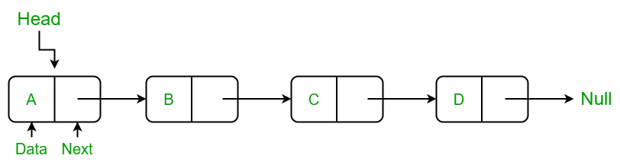

Arrays can be used to store linear data of similar types, but arrays have the following limitations:
- The size of the arrays is fixed: So, we must know the upper limit on the number of elements in advance. Also, generally, the allocated memory is equal to the upper limit irrespective of the usage.
- Insertion of a new element / Deletion of a existing element in an array of elements is expensive: The room has to be created for the new elements and to create room existing elements have to be shifted but in Linked list if we have the head node then we can traverse to any node through it and insert new node at the required position.
Example:
In a system, if we maintain a sorted list of IDs in an array id[] = [1000, 1010, 1050, 2000, 2040].
If we want to insert a new ID 1005, then to maintain the sorted order, we must move all the elements after 1000 (excluding 1000).
Deletion is also expensive with arrays until unless some special techniques are used. For example, to delete 1010 in id[], everything after 1010 has to be moved due to this so much work is being done which affects the efficiency of the code.
Advantages of Linked Lists over arrays:
- Dynamic Array.
- Ease of Insertion/Deletion.
Drawbacks of Linked Lists:
- Random access is not allowed. We must access elements sequentially starting from the first node (head node). So, we cannot do a binary search with linked list efficiently with its default implementation.
- Extra memory space for a pointer is required with each element of the list.
- Not cache friendly. Since array elements are contiguous locations, there is locality of reference which is not there in case of linked lists.
Types of Linked Lists:
- Simple Linked List – In this type of linked list, one can move or traverse the linked list in only one direction
- Doubly Linked List – In this type of linked list, one can move or traverse the linked list in both directions (Forward and Backward)
- Circular Linked List – In this type of linked list, the last node of the linked list contains the link of the first/head node of the linked list in its next pointer and the first/head node contains the link of the last node of the linked list in its prev. pointer
Basic operations on Linked Lists:
- Deletion
- Insertion
- Search
- Display

Representation of Linked List:
A linked list is represented by a pointer to the first node of the linked list. The first node is called the head of the linked list. If the linked list is empty, then the value of the head points to NULL.
Each node in a list consists of at least two parts:
- A Data Item (we can store integer, strings, or any type of data).
- Pointer (Or Reference) to the next node (connects one node to another) or An address of another node
In C, we can represent a node using structures. Below is an example of a linked list node with integer data.
In Java or C#, LinkedList can be represented as a class and a Node as a separate class. The LinkedList class contains a reference of Node class type.

Linked list representation in JavaScript:
<script>
let head;

class Node
{

constructor(variables) {
this.data = variables;
this.next = null;
}
}
</script>

Technology Used:
In order to make websites look and function a certain way, web developers utilize different languages. The three core languages that make up the World Wide Web are HTML, CSS, and JavaScript.
In the IT world, the internet is an essential platform, whether it`s for developing or for consumer use. When developing a website, typically three main languages come into play. These languages are JavaScript, CSS, and HTML. HTML is the backbone of most webpages. Essentially, it is used to create the structure of how a specific website would look like, from the headings to the paragraphs, the body, links, and even images.
Markup Languages:
Markup languages are the languages in which the web is written. The most common markup language used is HTML, which uses tags to annotate text so that a computer can then manipulate the text. Most markup languages are human readable and use annotations that are distinguishable from the annotated text. There are many kinds of markups and languages, but all are consistent in the way in which they annotate documents.
Hypertext:
Hypertext is defined as the arrangement of information inside a database that allows the user to receive information and to navigate from one document to another by clicking on highlighted words or pictures inside the primary document. Hypertext is the base of the World Wide Web, because it enables user to click on other links to get more information. Hypertext is a term used for all links, whether it appears as texts or other graphical part.
Hypertext Markup Language (HTML)
HTML is the conventional markup language used to create and edit web pages and web applications. HTML is used for creating the basic structure of a website. HTML consists of different elements preceded by an opening tag, <tag>, and a closing tag, </tag>. The content between the tags, <html> and </html>, is the content of the webpage. The content between the tags, <head> and </head>, is the title of the webpage. This text is displayed between the <title> and </title> tags. The content between the tags, <body> and </body>, is the main content of the webpage. The content can include links, paragraphs, headings, and various other elements.
Here are the most used HTML tags:

Tag | Description
<h1> - <h6> | Gives a web page a heading. 1 is the largest heading you can have and 6 is the smallest.
<p> | Starts a paragraph in your web page.
<a> | Inserts hyperlinks onto a web page.
<!DOCTYPE> | Defines the document type of the web page.
<!-- --> | Allows you to insert comments into your HTML code. Comments aren't displayed in on the web page but are helpful for organization.
<img> | Inserts an image onto a web page.
<br> | Inserts a line break between bodies of text.

Cascading Stylesheets (CSS):
CSS is a style sheet language standard set by W3C (World Wide Web Consortium) used to create and edit the visual presentation of web pages. CSS allows web developers to isolate a web page's content and visual styles into separate documents and gives better page layout control. An external CSS sheet is generally linked to HTML and XHTML, it also can be linked to XML, SVG, and XUL. HTML and JavaScript, with CSS, is a vital part of technology used by the majority of interfaces for websites. This is also used in interfaces for mobile devices making the websites more engaging.
Here are the most used CSS tags:

Tag | Description
background | A shorthand property for setting all the background properties in one declaration.
color | Sets the color of text.
opacity | Sets the opacity level for an element.
border | Sets all the border properties in one declaration.
border-color | Sets the color of the four borders.
/*...*/ | Allows you to insert comments into your CSS code. Comments aren't displayed in on the web page but are helpful for organization.
width | Sets the width of an element.
clear | Specifies which sides of an element where other floating elements are not allowed.

Types of CSS:
CSS can be incorporated with HTML in 3 different ways; Inline, Internal, and External.
- Inline styles add style to a single element on the page by placing 'style' after the element you wish to be styled.
Ex: h2 style = "color: blue"

- Internal styles create a style for a single document because the CSS is stored in the head of the HTML document. Internal styles are placed using a <style> tag around all style selectors.
- External style sheets exist in separate documents from HTML documents, allowing for better organization of style and structure. An external style sheet can be linked to all HTML documents making up a web site, allowing a web developer to style the entire site (all pages) using one document.
JavaScript:
JavaScript often abbreviated as JS, is a programming language that is one of the core technologies of the World Wide Web, alongside HTML and CSS. As of 2022, 98% of websites use JavaScript on the client side for webpage behavior, often incorporating third-party libraries. All major web browsers have a dedicated JavaScript engine to execute the code on users' devices.

JavaScript is a high-level, often just-in-time compiled language that conforms to the ECMAScript standard. It has dynamic typing, prototype-based object-orientation, and first-class functions. It is multi-paradigm, supporting event-driven, functional, and imperative programming styles. It has application programming interfaces (APIs) for working with text, dates, regular expressions, standard data structures, and the Document Object Model (DOM).

The ECMAScript standard does not include any input/output (I/O), such as networking, storage, or graphics facilities. In practice, the web browser or other runtime system provides JavaScript APIs for I/O.

JavaScript engines were originally used only in web browsers but are now core components of some servers and a variety of applications. The most popular runtime system for this usage is Node.js.

Website Snapshots:

Loading Animation:
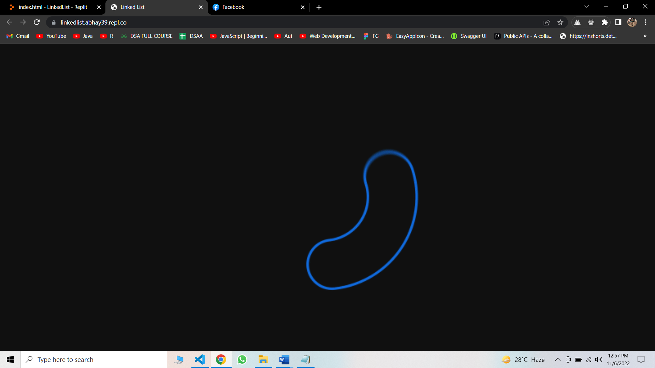
Homepage:
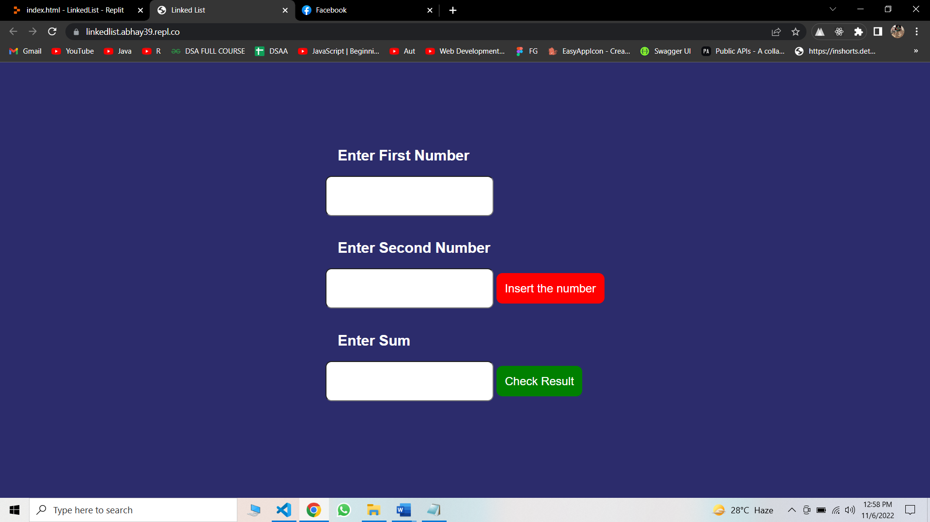
Entering the values:
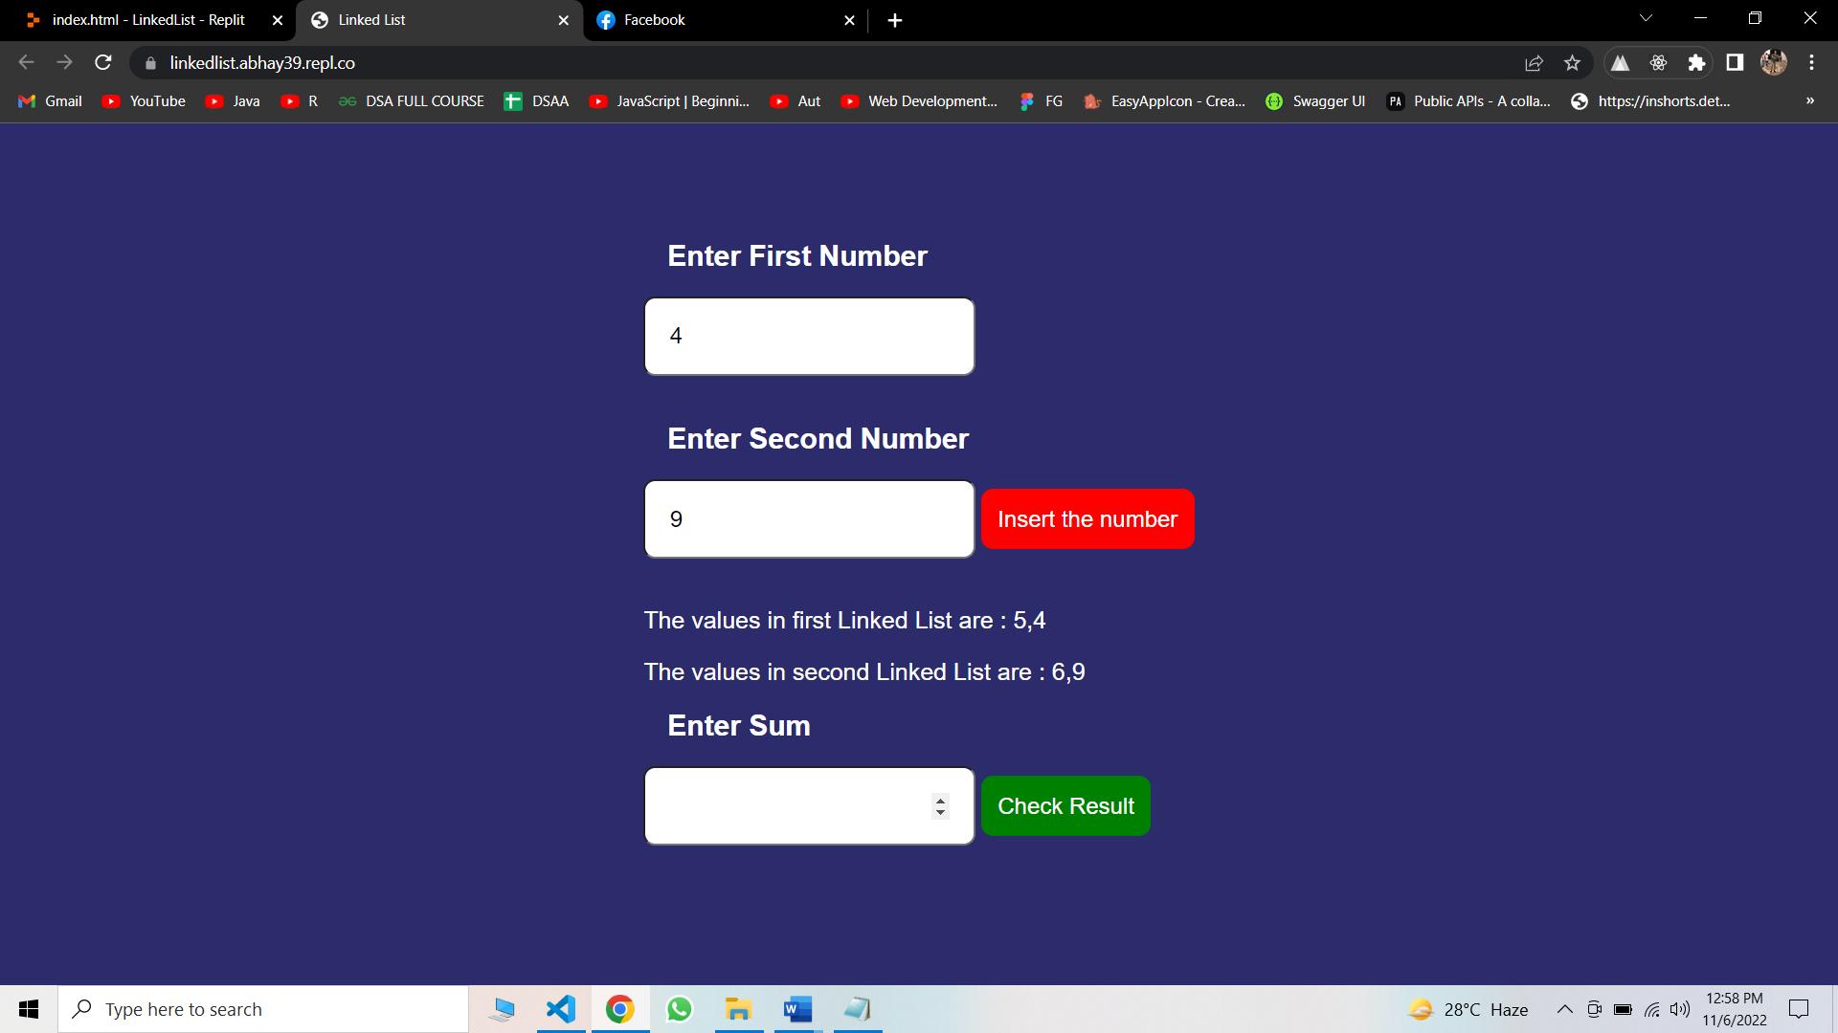

Checking Result:
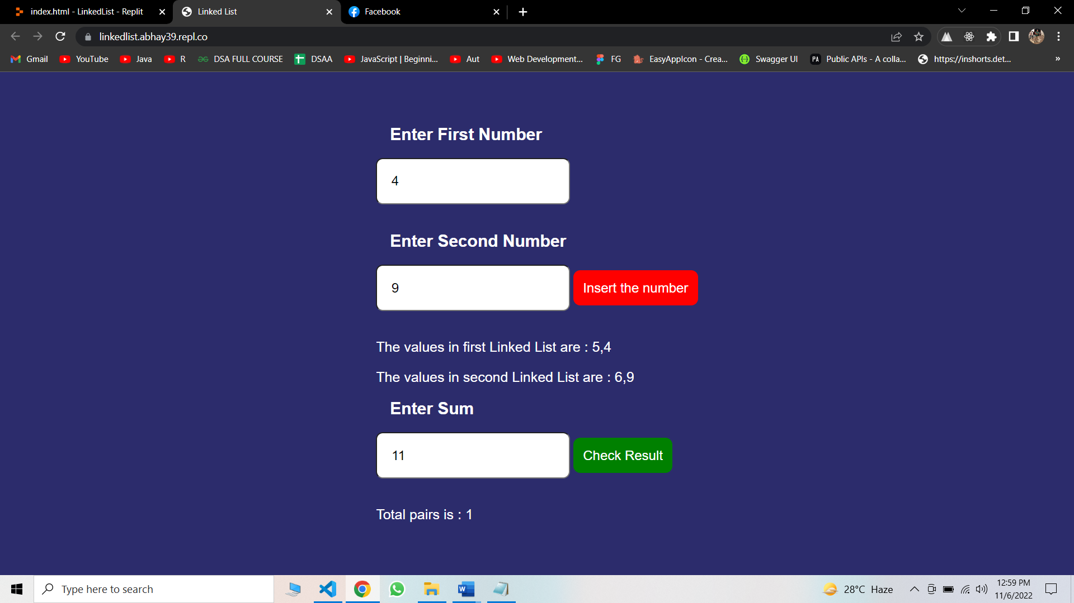

References:
  - Hosted Link : https://linkedlist.abhay39.repl.co/
  - GeeksForGeeks: https://www.geeksforgeeks.org/data-structures/linked-list/

